**Instructor and Researcher**

Cassandra Baker, Ph.D. is an instructor of business management at Gwinnett Technical College. Dr. Baker previously worked in the school of business and school of humanities teaching various business courses at the graduate and undergraduate level, writing and research at University of Phoenix. Prior to joining academia, Cassandra spent 15 years with Ford Motor Company and Volvo Cars of North America. She is a highly accomplished executive with experience in franchise management, organization management, financial management, and strategic planning within marketing sales & service.

**Academic Degrees**

Cassandra holds a PhD in Organization and Management from Capella University, Master of Business Administration from Brenau University and a B.S. in Business Administration from Shorter University. Her continuing education background includes professional training as Six Sigma Black Belt and Green Belt, Certified Sarbanes-Oxley, ISO Lead Auditor and Team Leader Myers-Brigg Certification. Dr. Baker is the owner Sugar Hill Research & Consulting and the author of Key Tools of Writing and Research: A Guide for the Student Writer on her belief in sharing knowledge and assisting students and organizations in achieving their goals can create win-win situations for all involved.

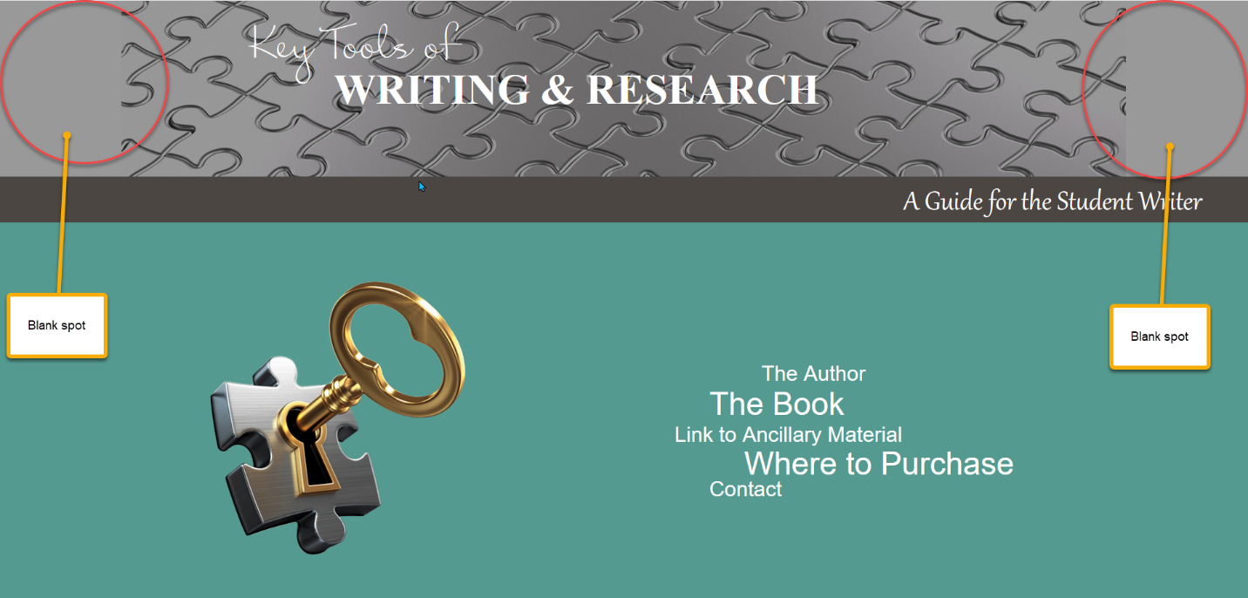

(Te mando aparte otra imagen con 2400 px de ancho)

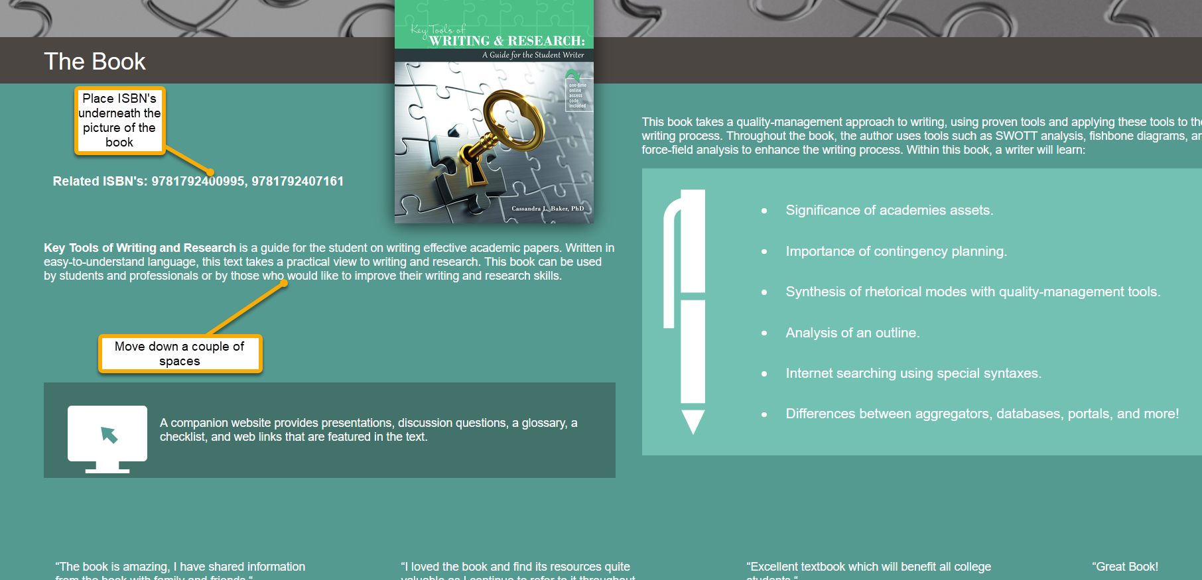



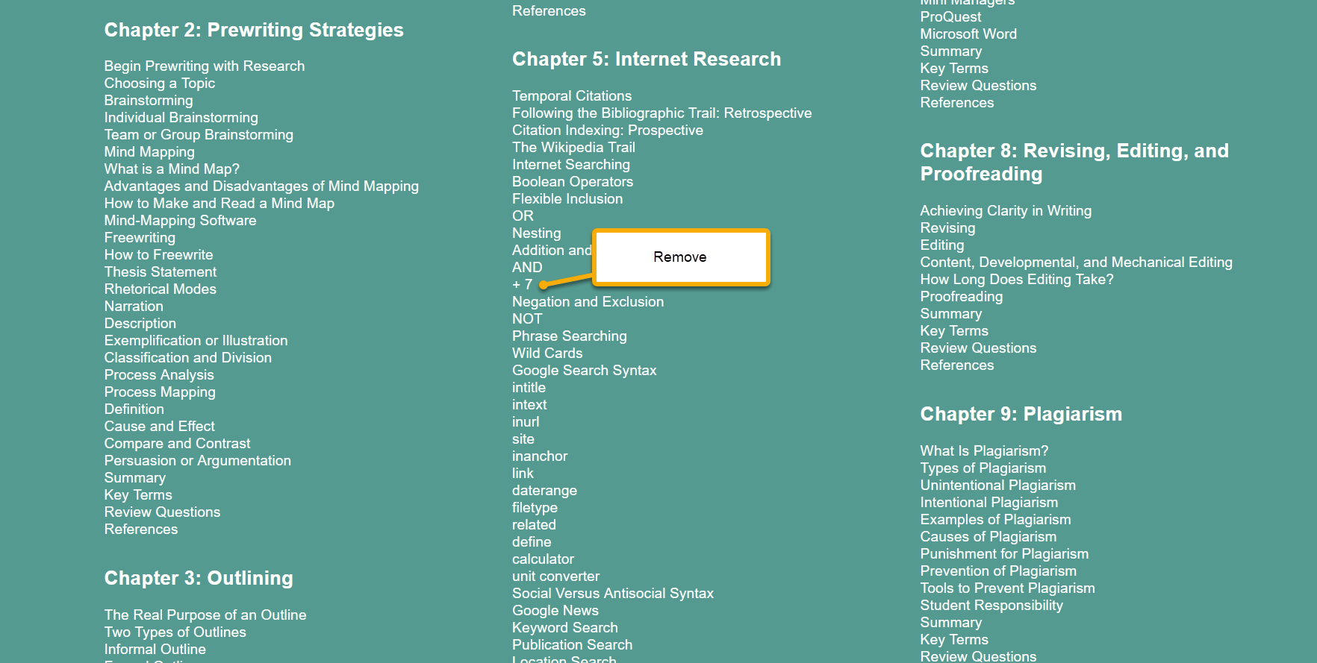

Remove first line in the left column

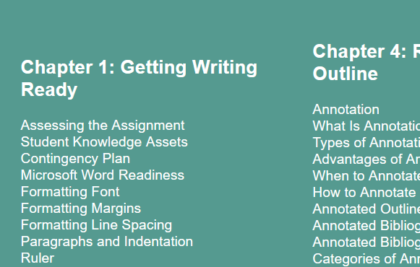

Remove related ISBN from here

